|  |  |  |
| --- | --- | --- |
| **Problem Chosen** A | **2024**  **MCM/ICM Summary Sheet** | **Team Control Number** 2413558 |

**Your Paper's Title**

**Summary**

Adaptive sex ratio variability has many dynamic effects on ecosystems. In the paper, we focus on the sex ratio variability of lamprey. The models developed include multi-population dynamic differential equation model, population stability test model, sex-resource consumption model and cellular automata model.

For problem 1, we simulated an ecosystem that included lamprey and other species in their food web. **A multi-population dynamic differential equation model** based on **Logistic model** and **Lotka-Volterra model** was used to analyze the impact of lamprey sex ratio variability on ecosystem. We found that the variability sex ratio variability increases the uncertainty of the ecosystem, affects the number and growth rate of multi-species populations, and this effect is transmitted and attenuated in the food web.

For problem 2, we analyze the advantages and disadvantages of lamprey in terms of population stability and sex-resource relationship. For the former, we considered the sex ratio factor on the basis of the Logistic model, and established a **population stability test model** to explore the coping ability of the lamprey population to the risk. For the latter, we establish a **sex-resource consumption model** based on the mass-energy relationship to explore the impact of the difference in resource consumption between males and females. Our results show that lamprey population is more resilient after destruction, but are more sensitive to environmental degradation and suffer from severe sex dysregulation in the presence of chronic resource shortages.

For problem 3, we established an ecosystem stability evaluation system through **EWM-Critic method** to quantify the impact of lamprey sex ratio changes on ecological stability. The model data in problem 1 was processed and transformed into scores for each metric, and the weighted sum was used to obtain the total score. The results showed that the ecosystem stability first increased and then decreased with the increase of the proportion of males, and the ecosystem was most stable when the proportion of males was about 56%.

For problem 4, parasites are studied as an example. We modeled **cellular automata** to simulate parasite transmission in lamprey populations. The simulation results show that there are significant differences in the speed and range of parasite transmission under different sex ratios of lamprey populations. The analysis showed that the presence of lamprey populations enhanced parasite resistance, reproduction rate and distribution range.

Finally, we perform sensitivity analysis and find that the model is sensitive to key parameters and overall robust. We also evaluate advantages and disadvantages of the model.

**Keywords:sex ratio, population dynamic model, EWM-Critic method,cellular automata**

**Contents**

1 Introduction 3

1.1 Problem Background 3

1.2 Restatement of the Problem 3

1.3 Problem Analysis 3

2 Assumptions and Justifications 4

3 Notations 5

Notations used in this paper 5

4 Problem 1: Multi-population dynamic differential equation model 5

4.1 Model building and improvement 5

4.2 Solution and result analysis 9

4.3 Ecosystem impacts of variable sex ratios of lampreys 10

5 Problem 2: Analysis of the advantages and disadvantages 10

5.1 Modelling of population stability tests 10

5.2 Gender-Resource Consumption Model 13

5.3 Strengths and weaknesses of the lamprey population 15

6 Problem 3: Ecosystem stability assessment on the EWM-Critic Method 16

6.1 Selection of evaluation indicators 16

6.2 Evaluation system based on EWM - Critic method 17

6.3 Results of the assessment of ecosystem stability under different sex ratios 19

7 Problem 4: Study of parasite populations based on cellular automata 20

7.1 Simulation of the life state of the lamprey 20

7.2 Visualisation of computer simulation results 22

7.3 Analysis and conclusion on the conditions of parasite reproduction 23

8 Sensitivity Analysis 24

9 Strengths and weaknesses of the model 24

9.1 Strengths 24

9.2 Weaknesses 25

References 25

# Introduction

## Problem Background

Sex is one of the important biological traits in the animal realm. Although many species exhibit a 1:1 sex ratio at birth, some species may have certain adaptive mechanisms to adjust the birth rates of male and female individuals in response to various environmental stresses. For these species, changes in sex ratio may be influenced by environmental conditions, resource availability, population density, and other factors. One interesting example is the lampreys.

The lamprey is a parasite that inhabits lakes and oceans and is very harmful to farmed fisheries[1].Changes in the sex ratio of sea lampreys at birth are closely related to their growth rate during the juvenile stage, which is influenced by food availability. The lower the food supply, the higher the proportion of males in the population. By delving into this characteristic of the lampreys, we can understand the dynamic effects of adaptive sex changes in the species on the population itself and on the ecosystem[2].

## Restatement of the Problem

Given the background introduction, problem statement, and additional guidance, the questions to be addressed are as follows:

1. Model and analyze the effects of this characteristic of lampreys sex ratios changing with population size on the components of the larger ecosystem.

2. Analyze the effects of the above characteristics on the lampreys population's own environmental adaptability and numerical stability.

3. Analyze the effects of changes in the sex ratio of the lampreys population on the stability of the ecosystem.

4. Analyze whether the change in the sex ratio of the lampreys population is beneficial to other species in the ecosystem, such as parasites.

## Problem Analysis

**For problem 1**, for the biological part of the ecosystem, we plan to combine and improve the Logistic model with the Lotka-Volterra model, and construct a population dynamic differential equation model to explore the impact of the sex ratio change of lamprey on the number of other populations. To simplify the model, we considered the sex ratio variability of lampreys to have essentially no effect on the abiotic fraction.

**For problem 2**, he advantages and disadvantages of lamprey populations can be explored from the perspectives of population stability and sex-resource relationship. It is hoped to establish a population stability test model based on the Logistic model to compare the stability of lamprey and other biological populations by simulating various changes in the population environment. At the same time, we wanted to explore the advantages and disadvantages of individual differences between male and female lampreys for the long-term development of the population.

**For proble**m **3** it is planned to establish an evaluation system for ecosystem stability. In order to make the evaluation as objective as possible, the Critic method is used to empower the index, and the entropy weight method is combined to improve it. We propose that alterations in the sex ratio of lamprey populations indirectly affect ecosystem stability by affecting the populations associated with them. The relevant data in question 1 can be used as the original data support.

**For problem 4**, parasites are taken as an example to consider whether other populations gain an advantage. Since parasite transmission mainly depends on the host, a cellular automata model can be established to simulate the trend of parasite transmission speed and range within the lamprey population infected by the parasite, and observe whether the sex ratio change of the lamprey is beneficial to the parasite.

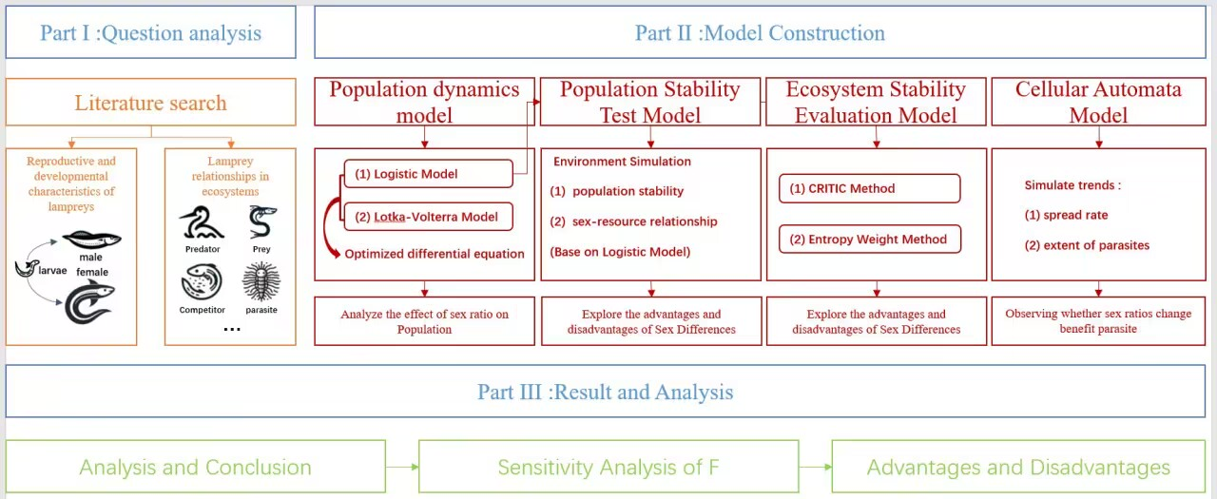

**Figure 1:** The frame of the article

# Assumptions and Justifications

**Assumptions 1:** Only populations directly associated with lampreys were considered for their effects on lampreys, and the interspecific relationships of these populations were not considered.

*Justifications: If the interspecific relationships of other populations are taken into account, the model will be too complex to solve.*

**Assumption 2:** It is assumed that all environmental conditions not mentioned in the model will remain relatively stable and appropriate and will not undergo.

*Justifications: Given the highly contingent and random nature of emergencies, which cannot be accurately predicted, it is impractical to take all environmental conditions into account.*

**Assumption 3:** Lampreys populations are fragmented, individual movements are random, and the rate of spread of parasites parasitizing lampreys is limited by the number of lampreys individuals in the vicinity.

*Justifications: Due to the unpredictable behavior of individual lampreys, it can be considered as a stochastic process and the parasite tends to move and reproduce near its host.*

**Assumption 4:** In a cellular automata (CA) model, a population of lampreys inhabits a 100*100 grid of closed aquatic ecosystems with no immigration or emigration. Population size is only affected by births and deaths, with a high probability of death for parasitised individuals.

*Justifications:This grid-based approach allows detailed modelling of life cycle dynamics and the effects of parasitism, capturing the intricate ecological interactions in a specific spatial context. This is critical for understanding the population dynamics and ecological balance of lamprey populations.*

# Notations

The key mathematical notations used in this paper are listed in Table 1.

Notations used in this paper

|  |  |
| --- | --- |
| **Symbol** | **Description** |
| *P* | proportion of male lampreys in the population |
| *F* | food availability index |
| *N* | population size of the lampreys |
|  | populations of organisms in competition with lampreys |
|  | population size of organisms that feed on lampreys |
|  | populations of organisms preyed upon by lampreys |
|  | populations of organisms parasitizing lampreys |
| *Nm* | environmental capacity |
| *r* | rate of population growth |

***Note: There are some variables that are not listed here and will be discussed in detail in each section.***

# **Problem 1:** Multi-population dynamic differential equation model

## Model building and improvement

In order to investigate the effects of the change of the sex ratio of the lampreys with food supply on other species in the ecosystem, it is necessary to quantitatively analyze the relationship between food supply and the population size of the lampreys, and comprehensively take into account the predation, competition and parasitism related to the lamprey, and then establish a population dynamics model by combining the Logistic model and the Lotka-Volterra model to investigate the long-term effects of the lampreys on the other species in the ecosystem affected in the long term.

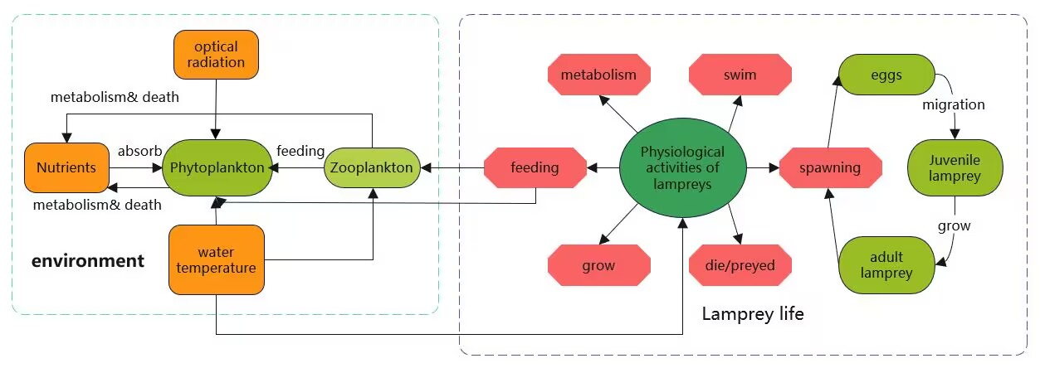**Figure 2:** Life activities of lamprey

### Relationship between food supply and population growth rate

Postulate the food supply index *F*, range 0-1, is the proportion of male lampreys individuals in the population, *b* is the birth rate of the lampreys population, *d* is the mortality rate of the lampreys population, and *r* is the natural growth rate of the population.

We assume that the proportion of males of the lampreys, and the food availability index, can be approximated as a linear relationship, and the formula for calculating is

|  |  |
| --- | --- |
|  | () |

whereis the proportionality coefficient and *P0* is a constant for the proportion of males in a population of lampreys s in a generalized environment. The values of bothand *P0* can be obtained by consulting the data.

For the birth rate , which can be approximated as being linearly related to , the formula for is

|  |  |
| --- | --- |
|  | () |

whereis a scaling factor related to the environmental capacity andis a constant of the birth rate of the population in the general environment. The values of both and can be obtained by consulting the data.

The mortality rate *d* is related to the number of predators , the number of competitors , the number of prey, and the number of parasitoids, and is calculated by the formula

|  |  |
| --- | --- |
|  | () |

where, , , and are the factors corresponding to the influence of the species on the mortality of the lampreys , respectively, andis the population mortality constant in the general environment.

The population growth rate is the difference between the birth rate and the death rate, so it is calculated as

|  |  |
| --- | --- |
|  | () |

### Population dynamics model of lamprey population

(1) logistic model

Considering only the lampreys population, the maximum population size that can be accommodated by the environment with limited resources is. As the population size increases, the constraints imposed by environmental factors on the population growth become more and more significant[3]. When the population size is small, the population growth rate can be regarded as a constant, and when the population size increases to a certain value, the growth rate should be regarded as a quantity that decreases with the increase of the population size[4]. From this, we can get the formula of

|  |  |
| --- | --- |
|  | () |

The growth rate = 0 when. So we have

|  |  |
| --- | --- |
|  | () |

So

|  |  |
| --- | --- |
|  | () |

Also by the Malthus model, , so there are

|  |  |
| --- | --- |
|  | () |

Ultimately

|  |  |
| --- | --- |
|  | () |

1. Lotka-Volterra model

Under natural conditions, there may be a variety of interactions between populations of organisms. We take into account the relationship between lampreys and their predators, and set the population growth rates of the two when they survive independently to be and , and the population size at the moment to be and. Due to the predation relationship, the population growth rate of the lampreys decreases, and the population growth rate of the predators increases[5].. Thus the equation is obtained

|  |  |
| --- | --- |
|  | () |

where reflects the predator's ability to feed on the predator and reflects the ability of the lamprey to feed on the predator.

(3) Improved modeling of population dynamics

To comprehensively consider the various factors affecting the population size of the lampreys, we combined the two models mentioned above and developed a new population dynamics model, which enabled the equation to consider the effects of both environmental factors and predators on the population size. In addition, we introduced other parameters related to the competitive and parasitic relationships between the lampreys and other organisms to make the model more accurate.

Postulatebe the population size of the competitor of the lampreys and be the population size of the parasite of the lampreys, and *N* is inversely correlated with both anddue to the competitive and parasitic relationship. Thus the equation can be obtained

|  |  |
| --- | --- |
|  | () |

where,, andare the environmental accommodations of predators, competitors, and parasites of the lampreys, respectively, and, , andreflect the predation capacity of the predator, the competition of the competitor, and the parasitism of the parasitoid, respectively, and since all of them can be regarded as constants, one can make , , and to end up with the differential equation

|  |  |
| --- | --- |
|  | () |

### Population dynamics model of **populations associated with lamprey**

Postulate , and be the population growth rates of competitors, parasitizers, and prey of the lampreys, respectively, and in conjunction with the equations for the population dynamics of the lampreys in 4.1.2, the differential equations for the population sizes of predators , competitors , parasitizers , and prey of the lampreys and versus time *t*, can be established in a similar manner:

|  |  |
| --- | --- |
|  | () |

|  |  |
| --- | --- |
|  | () |

|  |  |
| --- | --- |
|  | () |

|  |  |
| --- | --- |
|  | () |

where for , , , and reflect the ability of the sea lampreys to feed on predators, to compete with competitors, to feed on parasites, and to feed on prey, respectively. Thus the final set of differential equations is

|  |  |
| --- | --- |
|  | () |

## Solution and result analysis

In order to simulate the change in the number of various populations in the ecosystem over time, we set the initial value of time = 0, and the initial values of the population of the lampreys and its predators, competitors, parasitizers, and prey as = 250, = 120,= 125,= 85, and = 450 respectively. Utilizing MATLAB to solve the differential equations, we inputted the above parameters, and plotted the population number-time graphs as shown in Figure 3.

From Figure 3 we can observe that when the food availability index = 0.2, the number of predators and parasites of the lampreys gradually increases with time, while the number of competitors and prey of the lampreys gradually decreases. This shows that the presence of the lampreys has a wide range of effects up and down its food chain.

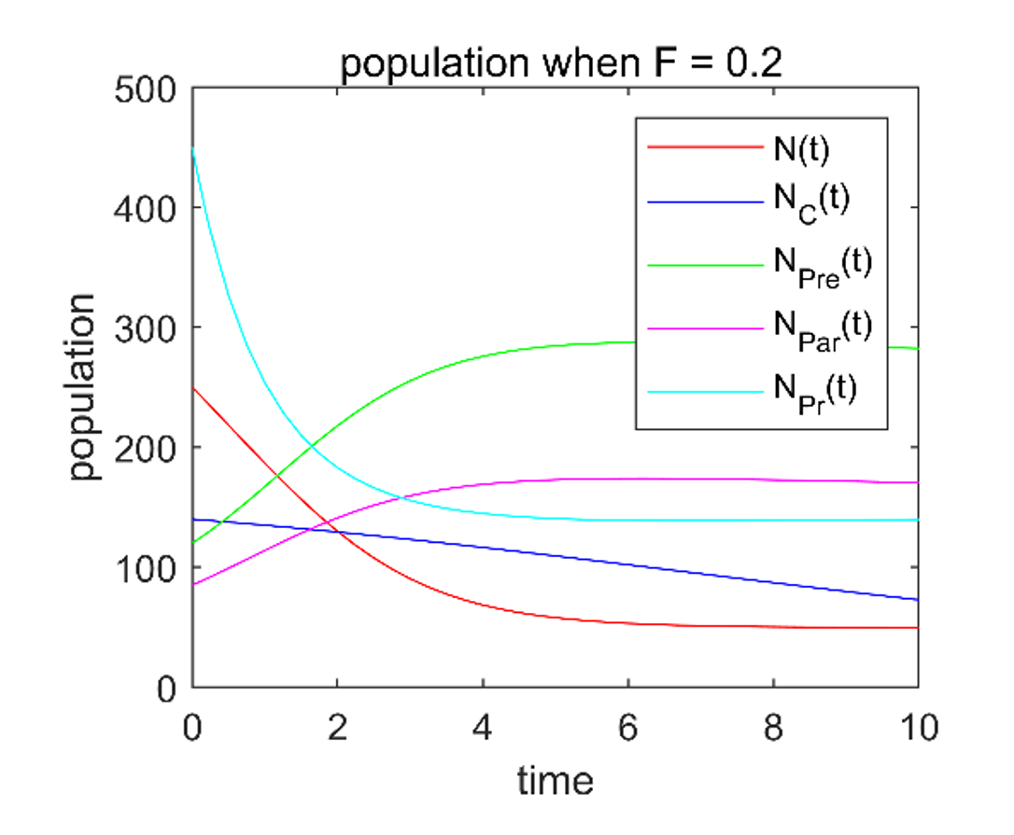

**Figure 3:**Trend of the population over time for *F*=0.2

Changing the food supply index *F* several times, the corresponding population size-time graphs when 0.2, 0.4, 0.6, 0.8 respectively were obtained, as shown in Figure 4. By comparison, it is easy to find that the equilibrium number of various populations and the time required to reach equilibrium all changed to some extent when the changes were made. Due to the intricate food relationship among the species in the ecosystem, the changes of these populations will in turn affect more populations related to them layer by layer with the food web, and this transmission is decreasing layer by layer.

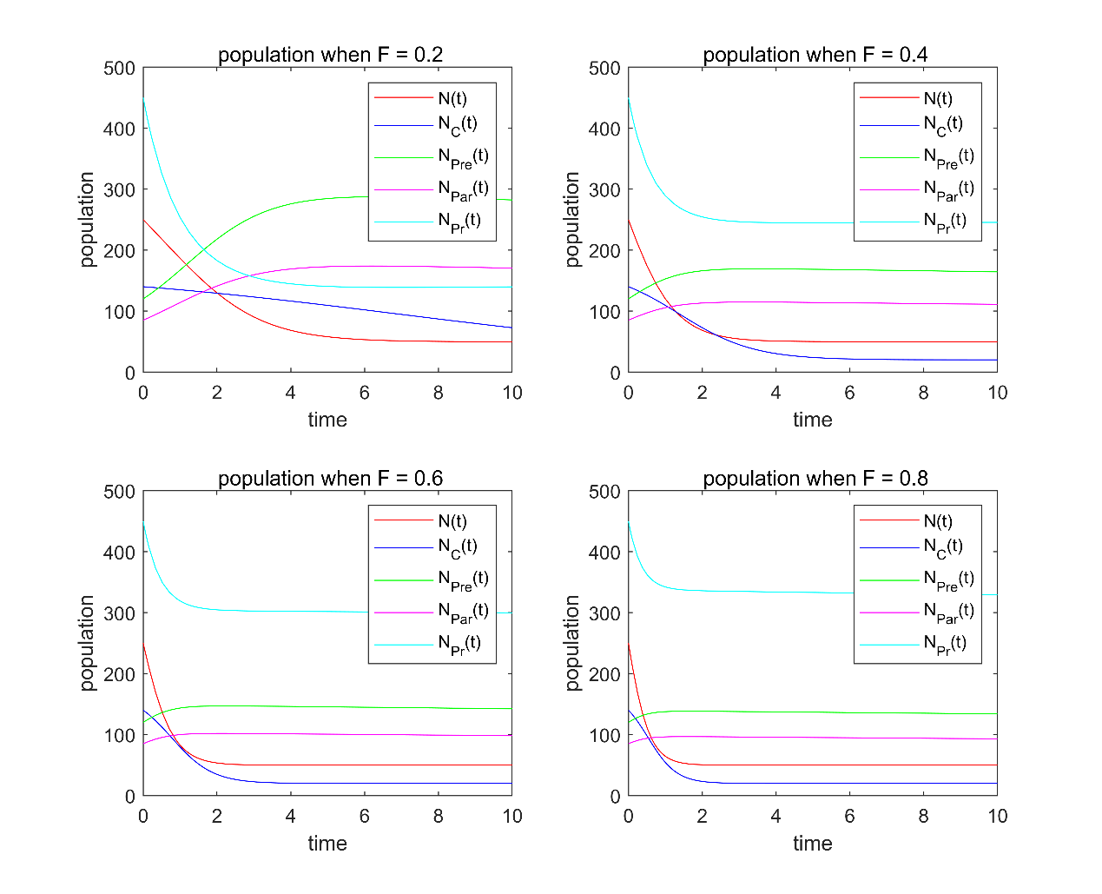

**Figure 4:** Trend of the population over time for different values of *F*

## Ecosystem impacts of variable sex ratios of lampreys

Since these changes arise because the food availability index constrains the sex ratio of lampreys, we can conclude that the variable sex ratio of lampreys makes the population size of species in the ecosystem that have a predatory, competitive, or parasitic relationship with lampreys , and the time it takes to reach the environmental capacity are all affected by the sex ratio of sea lampreys, and that this effect is transmitted and decays as it passes up through the levels of the food web with which they are associated.

# Problem 2: Analysis of the advantages and disadvantages

## Modelling of population stability tests

In order to examine the stability of the lampreys population, we established a population stability test model to observe and compare the coping ability of the lampreys and other biological populations to drastic changes by simulating the destruction of the population and the decline of food supply.

### Modeling

(1) For the lampreys population

Only considering the lampreys population, in 4.1.2 we have developed a logistic model of the form

|  |  |
| --- | --- |
|  | () |

within the population, as the number of individuals increases, intraspecific struggles intensify and food resources gradually decrease, defining the relationship between the food availability index *F* and *N* as

|  |  |
| --- | --- |
|  | () |

where is a normalization factor and is a constant independent of and .

From 4.1.1 we have derived a linear relationship between *F* and the growth rate *r*, which we simplify here as

|  |  |
| --- | --- |
| *r = a0F + b0­* | () |

where *a0* and *b0* can be introduced by the equations given in 4.1.1. Eventually we get the system of equations as

|  |  |
| --- | --- |
|  | () |

(2) For other biological populations with fixed sex ratio

For populations with a fixed sex ratio, the growth rate at the beginning of population development can be considered as a constant *r0*. According to the logistic model, the population growth equation is

|  |  |
| --- | --- |
|  | () |

### Situations where stocks are destroyed

Populations of organisms in nature are sometimes severely destroyed, such as by artificial culling or natural disasters. The resilience of populations after destruction is one of the attributes we are interested in.

The model is solved by writing and running MATLAB code. To simulate the destruction of lampreys and other species, we set the initial population size *N0* to a small value. In addition, to control the variables, we set the environment capacity of both to the same value. The prediction results at different are shown in Figure 5.

As can be seen from Figure 5, in the early stage of population development, the growth rate of lampreys population was significantly higher than that of other species with fixed sex ratios. Although the rate of growth of lampreys population gradually declined in the later period, it still reached the equilibrium point before other species. This may be attributed to the fact that in the early stages of development, lamprey populations are small and food is sufficient, so more lampreys developed into females, leading to higher birth rates and thus higher growth rates. While in the later period the population size increased and food availability decreased correspondingly, the impact on population growth in the later period is less than that in the earlier period. This suggests that lamprey populations are more resilient when populations are destroyed.

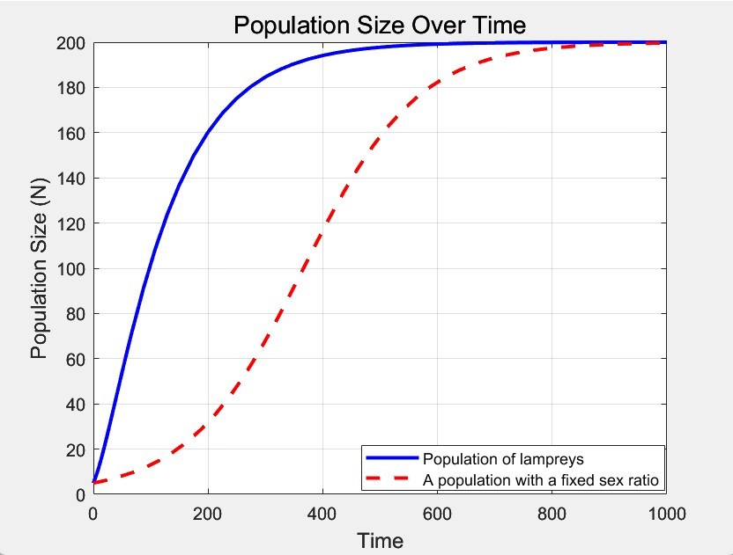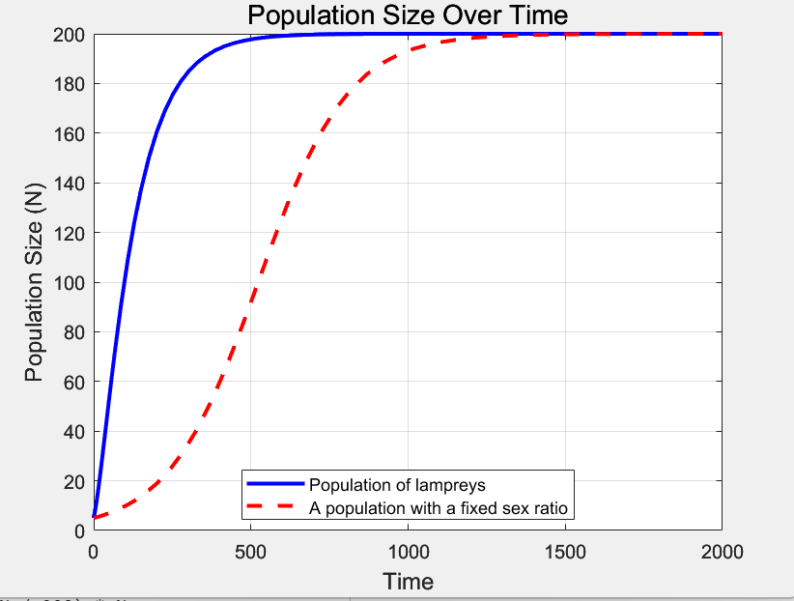

**Figure 5:** The trend of the population over time after the population is destroyed

### Situations where there is a sharp decline in food availability

When the environment changes rapidly, the food around the population may be drastically reduced. Simulating this situation can also be informative for studying the stability of lamprey populations.

As a result of environmental degradation, the environmental holding capacity of each population is reduced. Taking environmental changes into account, the model in pair 5.1.1 was slightly modified to obtain the equation for predicting the population size of organisms with fixed sex ratios as

|  |  |
| --- | --- |
|  | () |

The system of equations for predicting the population size of lamprey is

|  |  |
| --- | --- |
|  | () |

In the above equation, is the environmental impact factor andis the environmental resistance, which is related only to the degree of environmental harshness.

In order to simulate the environmental changes, the initial food supply index was set to a smaller value and the initial population size was close to the environmental capacity. Under different environmental impact factors , the predicted results are shown in Figure 6.

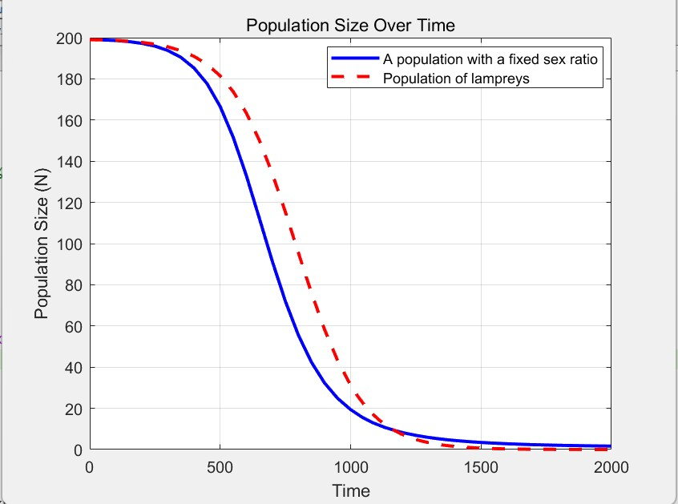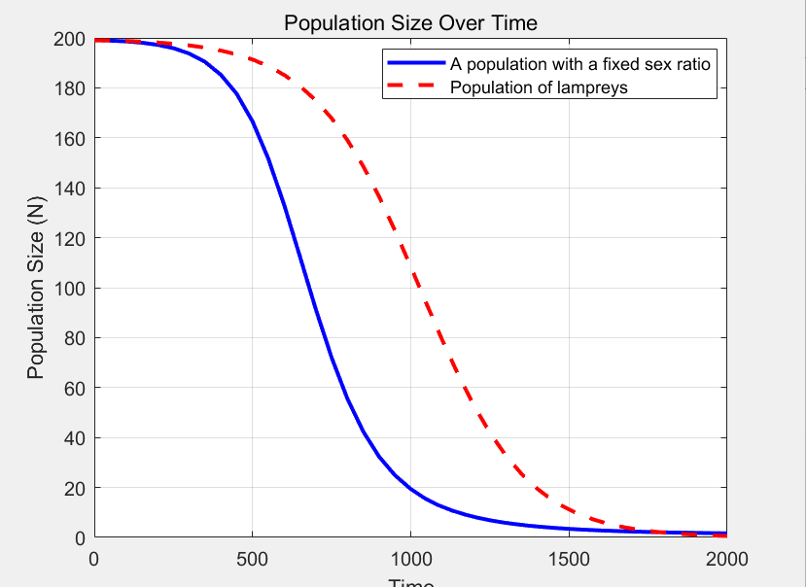

**Figure 6:** Trend of the population over time after food reduction

From Figure 6, we can see that the population size of the lampreys declined more rapidly than that of other organisms in the event of a sharp decline in food availability. This may due to the fact that when food resources are reduced, individual lampreys in the population tend to develop into males, resulting in a decrease in the proportion of female lampreys, a lower birth rate compared to other populations, and a greater negative population growth rate. This suggests that lampreys are more sensitive to environmental degradation.

## Gender-Resource Consumption Model

In order to investigate the resource depletion of the lampreys population, we have collected data on the differences in mass and length between males and females, established a sex-resource depletion model, and utilized the extreme value consideration method to calculate the resource space occupied by females and males respectively in the population. The changes in the sex ratio of the lampreys population were determined by modeling the situation of continuous lack of resources.

### Data collection and analysis

In order to improve the rationality and accuracy of the model, we limited our analysis to the population of Lei's lampreys, and we collected data related to the overall data of Lei's lampreys males, females, and the overall data of the whole length (X1), mass (Y), tail length (X2), head length (X3), and snout length (X4) as shown in Figure 7 (only part of it is shown), and for the mass as an indicator of the trait, the plotting of the Normal distribution histogram and its box-and-line plot are shown in Figure 7. Analysis of the data shows that the mass and body length metrics of male lampreys are significantly smaller than those of females.

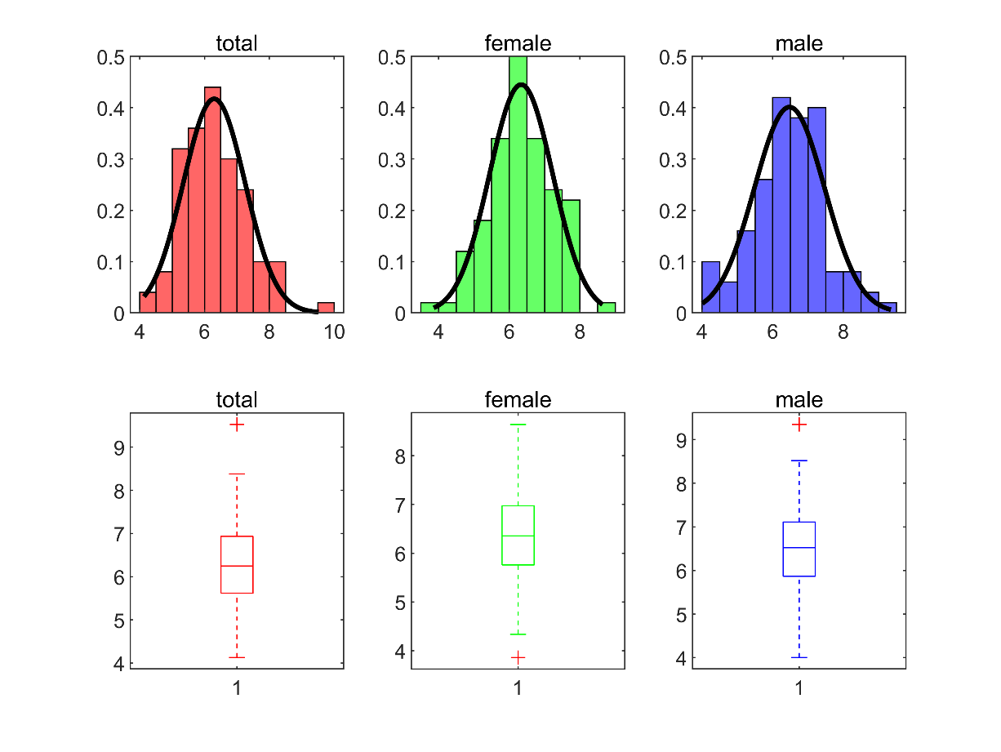

**Figure 7:** Mass distribution within the population of lamprey Reymus

After that, we used Kolmogorov-Smirnov chi-square test to test the normality of the quality indicators of the statistical population, and the test results showed that the significant levels of the quality of the male and female population of Lei's lampreys were 0.261 > 0.05 and 0.316 > 0.05, respectively, which indicated that there was no significant difference in the overall distribution of the quality of Lei's lampreys males and females, and that it approximately obeyed the normal distribution to the extent of 95%. This indicates that the overall distribution of mass within the Ray's lampreys male and female populations does not differ significantly from each other, and approximately follows a normal distribution at the 95% level, so that the data collected on the mean mass and length of individual lampreys can be used to represent the mean mass and length of individual males and females across the entire population of lampreys.

We analyzed the correlation coefficients of body mass (Y), total length (X1), tail length (X2), head length (X3), and snout length (X4), and obtained the correlation coefficients matrix as shown in Figure 8.

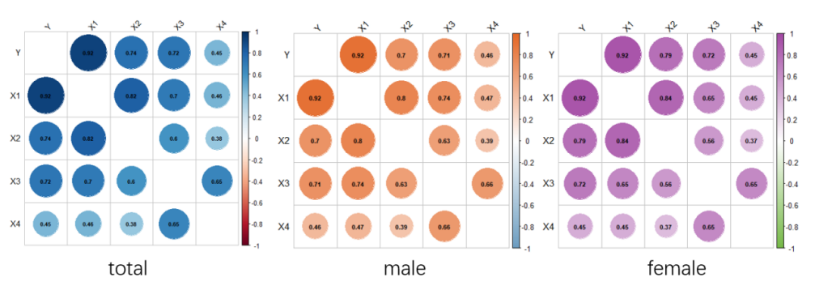

**Figure 8:** Correlation coefficient matrix for each trait

The results of the analysis showed that the body mass of Lei's lampreys was positively correlated with other shapes for both males and females, with the largest correlation coefficients for the trait of body length, which were 0.922, 0.922, and 0.925, respectively.Since mass is positively correlated with volume, we can substitute the body length of lampreys as an indicator of the volume, and solve the problem for the degree to which the lampreys can be accommodated in a limited spatial environment. Solve for the degree of containment in a restricted spatial environment.

### Resource consumption by individual males and females

Postulate and be the number of males and females in the population of the lamprey, respectively, and it is easy to obtain that

|  |  |
| --- | --- |
|  | () |

is the proportion of male individuals in the population, which is

|  |  |
| --- | --- |
|  | () |

Postulate and be the energy and space required for the survival of a single individual, and be the average mass and body length of an individual, and the subscripts 0 and 1 denote males and females, respectively. From the mass-energy relationship, we have

|  |  |
| --- | --- |
|  | () |

where is the qualitative energy factor and is the spatial factor. From this we can derive the maximum number of males and females, respectively, that the environment can accommodate as

|  |  |
| --- | --- |
|  | () |

where and are the maximum amount of energy and the maximum amount of space that an ecosystem can provide to a population of lampreys.

Substituting the average mass and average body length collected in 5.2.1 into the above equation, it is found that the calculation of is significantly larger than . Therefore, we can draw a preliminary conclusion that females are at a disadvantage in the population of lampreys because they consume more resources compared to males. In the natural state, the number of males is generally larger than that of females.

### A situation where resources continue to be scarce

Changes in the number of male and female individuals and their sex ratios of the lampreys population over time were analyzed by computer simulation of an environmentally extreme situation, as shown in Figure 9.

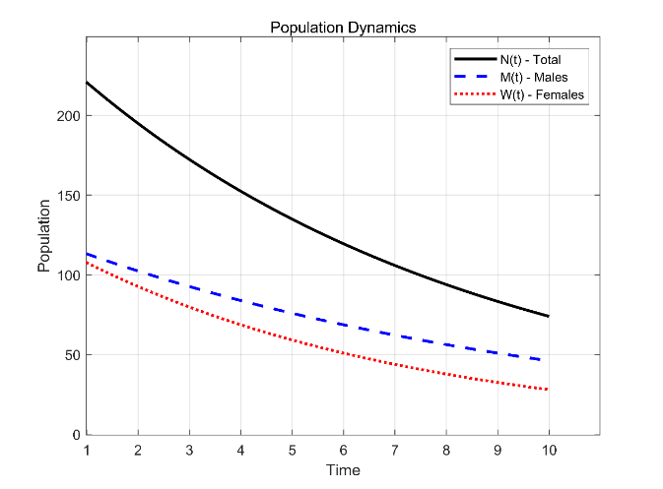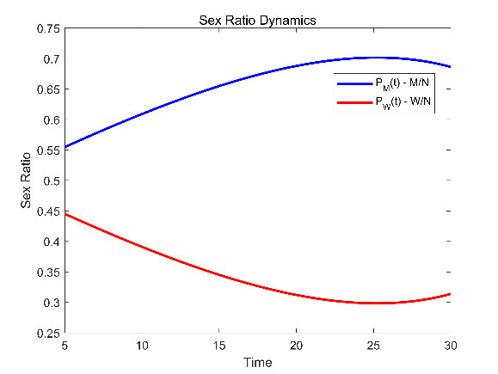

**Figure 9:**Trend of the number and proportion of male and female over time

Observing the graph of population-time dynamics we can observe that the number of individual lampreys declines continuously when there is a long-term lack of resources. However, comparing the curvature of decline of female and male lampreys we find that the number of female lampreys declines more rapidly. Comprehensively analyzing the sex ratio-time dynamics graph, we can see that the sex imbalance of the lampreys population is getting more and more serious with the passage of time, and the decrease of the proportion of female lampreys will lead to the birth rate of the lampreys population to be greatly reduced, which is not conducive to the development of the population in the long term.

## Strengths and weaknesses of the lamprey population

(1) Advantages

According to the scenario of population destruction simulated by the population stability test model, the lampreys population has a stronger ability to recover compared to other sex-fixed populations. This suggests that the lampreys population is able to recover to its original level more quickly when the population is heavily reduced by factors such as artificial harvesting.

(2) Disadvantage

According to the population stability test model simulating the situation of drastic reduction of food, the population of lampreys is less tolerant compared to other populations with fixed environmental sex. This suggests that the lampreys population declines more rapidly when food availability is drastically reduced.

According to the sex-resource depletion model, due to differences in resource consumption between males and females, severe gender dysphoria occurs within lampreys populations during times of persistent resource scarcity, making them more susceptible to the threat of genocide.

# Problem 3: Ecosystem stability assessment on the EWM-Critic Method

## Selection of evaluation indicators

Ecosystem stability refers to the ability of an ecosystem to maintain its structure and function in the face of external perturbations. There are many indicators affecting ecosystem stability, including species richness, ecosystem resistance and ecosystem resilience[6]. Here we examine the stability of ecosystems from five aspects: population volatility, interspecific relationship stability, species richness, resistance stability and resilience stability

* **population volatility (*I1*):**

Population volatility refers to the fluctuation or variation degree of the number of individuals in a biological population over time, which can directly or indirectly affect the overall stability of the ecosystem [7].

* **Interspecific relationship stability (*I2*):**

Interspecific relationship stability refers to the degree of stability of interactions between different species in an ecosystem. Such interactions include various ecological relationships such as predation, competition, and symbiosis.

* **Species richness (*I3*):**

Species richness refers to a measure of the number of different species present in a given area or ecosystem. It is an important part of maintaining the stability of the ecosystem.

* **Resistance Stability (*I4*):**

Resistance stability refers to its ability to resist external disturbances or stresses. When ecosystems are faced with various pressures, systems with high resistance are better able to maintain the stability of their internal structure and function, thus maintaining the overall stability of the ecosystem[8].

* **Resilience Stability (*I5*):**

Resilience stability refers to the ability of an ecosystem to regain its original state after being disturbed. Highly resilient ecosystems are able to quickly return to their original state after being disturbed, thus maintaining their stability.

In the marine environment, lampreys are mainly parasitized by salmonids, there is competition between them and other predatory fish, sometimes waterbirds prey on lampreys, and some parasites parasitize lampreys. We believe that the change of the sex ratio of the lampreys can indirectly affect the above five indicators by affecting the four organisms: waterbirds (*N1*), salmon (*N2*), predatory fish (*N3*), and parasites (*N4*).

## Evaluation system based on EWM - Critic method

In order to get more objective evaluation results, we use the population dynamic differential equation model obtained in Task 1, and take the number of various populations at the time of stabilization under the condition of different initial values of sex ratio as the original data. At the same time, in order to avoid subjectivization, we choose Critic method for assignment and improve it by combining with entropy weighting method. Critic method is a kind of objective assignment method based on the comparative strength of evaluation indexes and the conflict between indexes to comprehensively measure the indexes.

### Data matrix construction and normalisation

*N1*, *N2*, *N3*, *N4* denote waterbirds, carp, predatory fish, and parasites, respectively, and *I1*, *I2*, *I3*, *I4*, *I5* denote the five indicators of population volatility, stability of interspecies relationships, species richness, resistance stability and resilience stability, respectively. *Ni* denotes the *ith* species and *Ij* denotes the *jth* indicator.

In order to establish the link between organisms and indicators, we use the population dynamic differential equation model in Problem 1 to get the number of various populations when they are stabilized under the condition of different initial values of the sex ratio, and use it as the raw data. The data matrix can be obtained by applying some transformations to the raw data (see 6.2.3 for specific transformation formulas):

|  |  |
| --- | --- |
| *X = (xij)m×n­* (1≤*i*≤*m*, 1≤*j*≤*n* ) | () |

where *m* = 4, *n* = 5, and *xij* is the corresponding score of the *ith* organism for the *jth* indicator. Since the indicators used are positive indicators, data normalization is required, and the elements within the data matrix are set to be after normalization, which is given by the following equation

|  |  |
| --- | --- |
|  | () |

### Assignment of weights to indicators (*Wj*)

Indicator weights indicate the importance of each indicator for ecosystem stability assessment. In the Critic weight method, we need to calculate the magnitude of indicator variability and conflict respectively, and then calculate the information carrying capacity of the indicators based on these data, and finally get the magnitude of each indicator weight. *Wj* denotes the indicator weight of *Ij*.

The variability of  *Ij* is first calculated. The variability of the indicator is measured by the standard deviation of each column of data, which is calculated as follows:

|  |  |
| --- | --- |
|  | () |

The conflictability of indicators is related to the correlation coefficient. Let the conflictability between *Ij* and the rest of the indicators be with the following formula:

|  |  |
| --- | --- |
|  | () |

where is the correlation coefficient between *Ii* and *Ij*.

The greater the indicator variability indicates that the greater the numerical difference of the indicator, the more it can reflect more information, the stronger the evaluation strength of the indicator itself, and the more weight should be assigned to the indicator; while when an indicator is closely related to other indicators, it reflects more of the same information, with less conflict, so the weight assigned to the indicator should be reduced. Based on the indicator variability and conflict, the information carrying capacity *Cj* of *Ij* can be defined:

|  |  |
| --- | --- |
|  | () |

The larger is, the greater its role in the whole evaluation index system, the more weight should be assigned to it.

Ultimately, it can be concluded that the objective weight *Wj* of *Ij* is

|  |  |
| --- | --- |
|  | () |

However, the Critical method has some drawbacks, for example, the correlation coefficient may be positive or negative, so it is more appropriate to use (1 - |*rij*|) instead of (1 - *rij*) in the original method when reflecting the strength of comparison between indicators; the Critical method, although it can effectively take into account the fluctuation and correlation between the indicator data, does not consider the degree of dispersion between the indicator data. Although the Critic method can effectively consider the volatility and correlation between the indicator data, it does not consider the degree of dispersion between the indicator data. Therefore, the entropy weight method can be utilized to improve the Critic method so that the improved Critic method can fully consider these three major attributes. The formula for calculating the improved weights is as follows

|  |  |
| --- | --- |
|  | () |

### Calculation of ratings

We take the stabilized number of various groups under different sex ratio conditions as raw data and denote the stabilized number of *Ni* by *Yi*. In order to obtain the score of *Ni* against *Ij*, the following transformations need to be made:

|  |  |
| --- | --- |
|  | () |

where denotes the biological weight of *Ni* on *Ij*, which is the importance of each organism for each indicator.

Accordingly, we can calculate the composite score for the *jth* indicator:

|  |  |
| --- | --- |
|  | () |

Ultimately, the overall ecosystem stability score was obtained by multiplying the composite score with the corresponding indicator weights:

|  |  |
| --- | --- |
|  | () |

## Results of the assessment of ecosystem stability under different sex ratios

To quantify population volatility and connectivity, we have modeled an ecosystem that includes waterfowl, carp, predatory fish, parasitoids, and lampreys. In solving Task 1, we have modeled a population dynamics differential equation that includes multiple species. Different initial sex ratios of lampreys populations were set, and the model was utilized to derive the raw data and calculate the overall ecosystem stability scores for the different scenarios based on an evaluation system based on the Critic method improved using the entropy weight method (EWM).

The solution was carried out using MATLAB. Taking the male ratio P = 0.75 as an example, the scores obtained at this point for the four organisms for each indicator are shown in the Table 1 below.

**Table 1:** The rating of each indicator by the four organisms

|  |  |  |  |  |  |
| --- | --- | --- | --- | --- | --- |
| *Type* | *I1* | *I2* | *I3* | *I4* | *I5* |
| *N1* | 85 | 92 | 78 | 88 | 91 |
| *N2* | 90 | 88 | 82 | 85 | 84 |
| *N3* | 75 | 80 | 85 | 82 | 87 |
| *N4* | 99 | 89 | 65 | 78 | 83 |

Substituting the data into the formula given in 6.2, the variability, conflict, information carrying capacity, and the final weighted value share of each indicator is obtained as shown in the Table 2 and figure 10.

**Table 2:**Weight information of the indicators

|  |  |  |  |  |
| --- | --- | --- | --- | --- |
| *targets* | *variability* | *Conflict* | *information carrying capacity* | *Weight(%)* |
| *I1* | 10.012 | 5.207 | 52.136 | 39.77 |
| *I2* | 5.123 | 3.328 | 17.049 | 13.005 |
| *I3* | 8.813 | 4.386 | 38.652 | 29.484 |
| *I4* | 4.272 | 2.702 | 11.544 | 8.806 |
| *I5* | 3.594 | 3.259 | 11.713 | 8.935 |

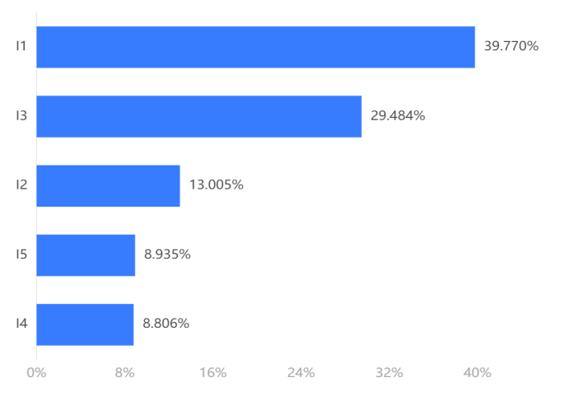

**Figure 10:** Distribution of the proportions of the five indicators

The composite scores of each indicator were weighted and summed, and the total ecosystem stability score at *P* = 0.75 was finally obtained as 86.

The values of were changed several times to obtain the corresponding stable numbers of various groups and the total ecosystem stability score, and scatter plots were plotted and fitted, respectively, as shown in Figure 11.

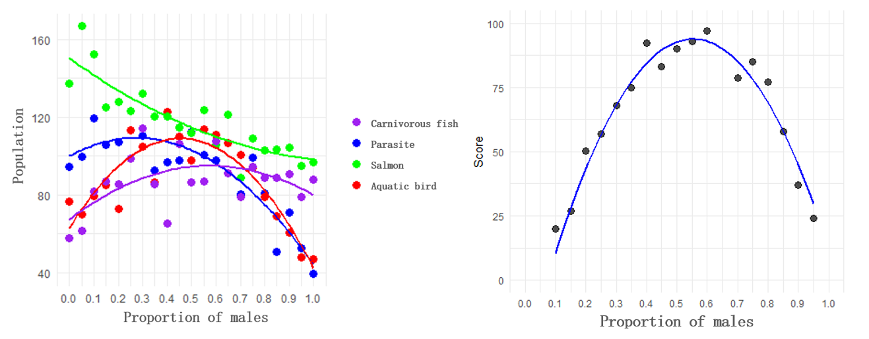

**Figure 11:**Fit of population number and score

As can be seen from the fitted graph, the overall ecosystem stability total score shows a general trend of increasing and then decreasing as the *P* value increases. The score reached its maximum value when *P* was about 0.56. This indicates that the stability of the ecosystem first increases and then decreases when the proportion of male lampreys increases, and the ecosystem is most stable when the proportion of males is 0.56.

# Problem 4: Study of parasite populations based on cellular automata

## Simulation of the life state of the lamprey

We calculated the results of the population dynamics of lampreys and their parasitizers based on the population dynamics model constructed in Problem 1, and analyzed the survival rate of lampreys of different ages and whether they were parasitized or not under limited conditions. Considering only lampreys and parasites, we constructed a cellular automaton to simulate the population size and distribution range of parasites parasitizing lampreys in a unified ecosystem under different sex ratios of lampreys populations, and then evaluated and analyzed whether the conditions for parasite reproduction had been significantly improved.

A cellular automaton (CA) is a mathematical model for simulating the dynamic behavior of complex systems[9].It consists of a regular grid, each of which is called a "cell". Each tuple is in a state in a finite set of states. The state of a tuple evolves in time according to a fixed set of rules that take into account the current state of the tuple and its neighboring tuples.

A standard tuple automaton (A) consists of tuples, tuple states, neighborhoods, and state update rules. It is represented in mathematical form:

|  |  |
| --- | --- |
| *A* = ( *L*, *d*, *S*, *N*, *f* ) | () |

where *L* is the space of tuples, *d* is the dimension of the space of tuples within a tuple automaton, *S* is the finite, discrete set of states of a tuple, *N* is the set of all tuples in a given domain, and *f* is a local mapping or local rule.

We set a 100*100 matrix to simulate the ecological space of this water body, and each metacell state is represented by 0~6. In the local mapping *f* we consider the metameric states of the current lattice point and its neighboring eight surrounding lattice points to determine its next state, which is expressed by equation:

|  |  |
| --- | --- |
|  | *()* |

where *Sij* represents the metameric state of the lattice point in the *i*th row and *j*th column.

To simulate the life cycle of the lamprey, we make the following definitions of states:

State 0: virtual water space, indicating an area where no lamprey exist

State 1: Juvenile lamprey, indicating a newly hatched lamprey

State 2: Adult male lamprey

State 3: Adult female lamprey

State 4: Parasitized adult male lamprey

State 5: Parasitized adult female lamprey

State 6: Parasitized juvenile lamprey

Through an iterative process, we are able to model the dynamics of the lamprey during its life cycle. Each iterative step consists of the following main actions:

* Random movement: simulates the movement of the lamprey in the water column. If there is an empty space (state 0) around a metazoan (representing a lamprey), it may randomly move to that location.
* Death judgment: each lamprey state has a certain probability of death, simulating natural death and the high mortality rate caused by being parasitized. If a random event falls within the death probability, the metacercaria will change back to a virtual aquatic space state.
* Birth judgment: if a virtual aquatic space metacell (state 0) is surrounded by a specific configuration of neighbors (e.g., a certain number of adult male and female lamprey), it may change to a juvenile lamprey, simulating the reproduction process.
* Parasitism judgment: if adult or juvenile lampreys are surrounded by parasitized lampreys, they may also change into the corresponding parasitized state, simulating the effect of the parasitism process on the population.

we design our own algorithm to achieve the simulation of the lamprey being parasitic state. The pseudocode is as follows:

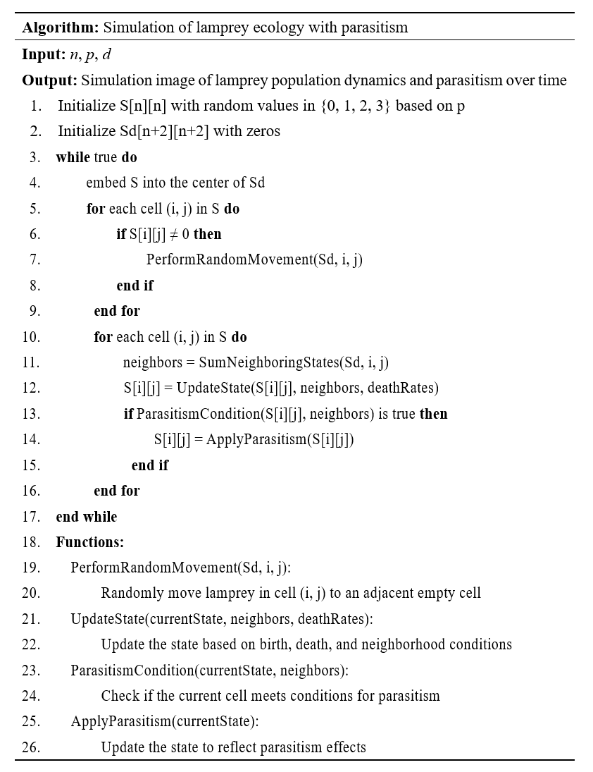

## Visualization of computer simulation results

In order to solve problem IV, we focus on the number and distribution state of the parasitized lampreys. When an individual lamprey is parasitized, its probability of death doubles. In order to model changes in the sex ratio of lampreys, we set up different proportions of juvenile lampreys developing into males or females. To make the model fit realistic time as simplistically as possible, we treated one iteration of the model as one day.

To prevent the visualization of the state from having too much color variety for easy observation and analysis, we colored only the parasitized lamprey metazoans in the metazoan automaton model run. Figure 12 shows a summary of the metacellular automata simulation visualization.

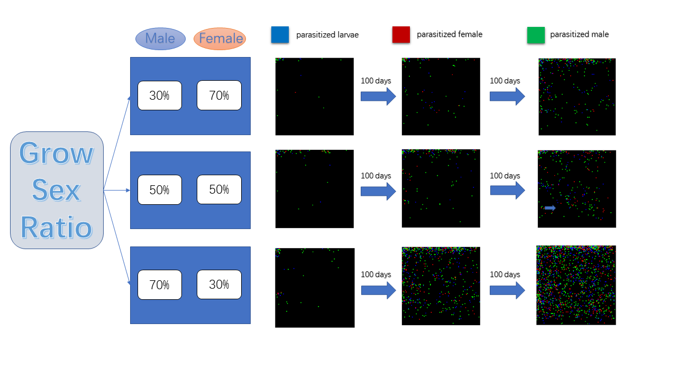

**Figure 12:**Visualization of a cellular automaton

As can be seen in Figure 12, the number of parasitized lampreys gradually increased over time. There was a significant difference in the number of parasitized individuals in the population of lamprey at the same time under different sex development probabilities. When the probability of juvenile lampreys developing into males was 70% and the probability of females was 30%, the parasites parasitizing lampreys grew more in population size over the same time period and had a wider distribution in our simulated water environment.

Combining the relationships between the probability of developing into a male, the birth probability and the number of parasitized individuals, we plotted a three-dimensional surface map, as shown in Figure 13.

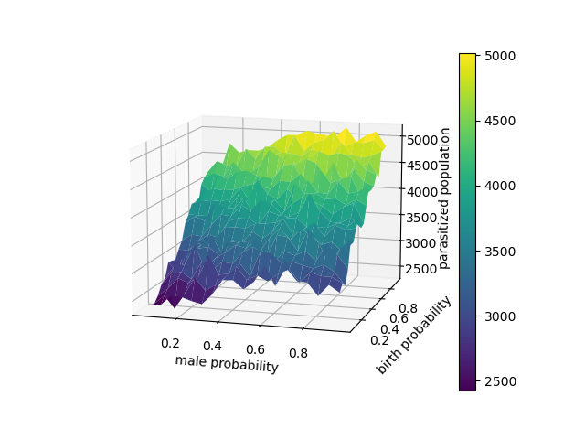

**Figure 13:**3D diagram related to the parasitized lamprey

## Analysis and conclusion on the conditions of parasite reproduction

From the visualization results of 7.2, we found that as the probability of juvenile lampreys developing into males gradually increased, the number of parasite groups parasitizing lampreys gradually increased and their distribution was wider. This may be due to the fact that the survival ability of male lampreys is stronger and the survival rate of parasites parasitized on male lampreys is higher. Under poor environmental conditions, the availability of food for lampreys is reduced, and the probability of juvenile lampreys developing into males is higher, which is more favorable to the reproduction and spread of the parasite. Therefore, it can be concluded that for ecosystems with the presence of lampreys, the parasites are more resistant to the environment, have a higher reproduction rate, and have a wider distribution.

# Sensitivity Analysis

In the population dynamics model, in order to test the effect of changes in the F value of the food availability index, we changed the *F* value several times in the interval [0.45, 0.55], and observed the changes in the trend graph of the predator population number as an example. The prediction results are shown in Figure 14.

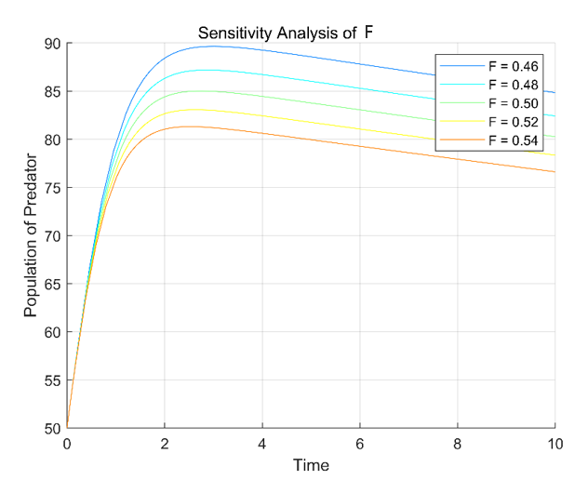

**Figure 14:** Sensitivity analysis of F

When *F* varies within a certain range, a significant change in predator population size can be observed, indicating that the established model is more sensitive to *F*. Moreover, the overall trend of predator population size over time is basically unchanged, indicating that the model does not show obvious bias and is more reliable.

# Strengths and weaknesses of the model

## Strengths

* The model is based on a rigorous mathematical-physical model and is reasonably corrected in the light of the actual situation, so that it is capable of making short-, medium- and long-term forecasts.
* The model takes into account the relationship between populations as well as the relationship within populations, which is comprehensive and systematic, has good reproducibility and is highly consistent with the actual situation.
* The EMW-Critic model obtained by combining the Critic weighting method and the entropy weighting method can take into account the advantages of both methods, which makes the model fully consider the three major attributes, namely, volatility, correlation and degree of dispersion of the indicator data.

## Weaknesses

* The ecological network constructed is relatively simple, only considering the influence of the lamprey population and its related populations, but ignoring the complex interspecific relationships between other populations, which cannot fully reflect the complexity and diversity of the ecosystem where the lampreys is located.
* The rules of the cellular automata are relatively simple, which cannot accurately capture all the dynamics of the lamprey population, resulting in some deviations of the model simulation results relative to the real situation.

# References

Li, J., Ma, Q. H., Xu, L. (2018). Correlation analysis of morphological traits with body mass and sexual dimorphism in Reissner&apos;s lamprey from the Yalu River. Journal of Fisheries of China, (05), 19-28.

Wang, C. Y. (2020). Dynamics stability of a class of predator and prey ecological systems. Master&apos;s thesis, Anqing Normal University.

Holmes, E. E., Lewis, M. A., Banks, J. E., & Veit, R. R. (1994). Partial differential equations in ecology: spatial interactions and population dynamics. Ecology, 75(1), 17-29.

Tsoularis, A., & Wallace, J. (2002). Analysis of logistic growth models. Mathematical biosciences, 179(1), 21-55.

Takeuchi, Y., Du, N. H., Hieu, N. T., & Sato, K. (2006). Evolution of predator–prey systems described by a Lotka–Volterra equation under random environment. Journal of Mathematical Analysis and applications, 323(2), 938-957.

Pimm, S. L. (1984). The complexity and stability of ecosystems. Nature, 307(5949), 321-326.

Ives, A. R., & Carpenter, S. R. (2007). Stability and diversity of ecosystems. science, 317(5834), 58-62.

Johnson, K. H., Vogt, K. A., Clark, H. J., Schmitz, O. J., & Vogt, D. J. (1996). Biodiversity and the productivity and stability of ecosystems. Trends in Ecology & Evolution, 11(9), 372-377.

Li, W., & Packard, N. (1990). The structure of the elementary cellular automata rule space. Complex systems, 4(3), 281-297.